Map Colouring Problem using CSP:
Aim:
To write a Python program to solve the Map Colouring problem using Constraint Satisfaction Problem (CSP).
Objective:
- To understand the concept of Constraint Satisfaction Problems (CSP) in Artificial Intelligence.
- To implement the Map Colouring problem using Python.
- To represent variables, domains, and constraints in a CSP.
- To use backtracking search to find a valid colouring solution.
- To ensure that adjacent regions have different colours.
- To understand how CSP can be used to solve real-world problems.
Algorithm:
- Start
- Define the map with all regions and their neighbouring regions.
- Define the available colours, such as Red, Green, and Blue.
- Select an uncoloured region.
- Assign a colour to the selected region.
- Check whether the colour satisfies the constraint:
  - Neighbouring regions must have different colours.
- If the colour is valid, move to the next region.
- If the colour is not valid, try another colour.
- If no colour is possible, backtrack to the previous region and change its colour.
- Repeat until all regions are coloured.
- Display the map colouring solution.
- Stop.

Flow Chart:
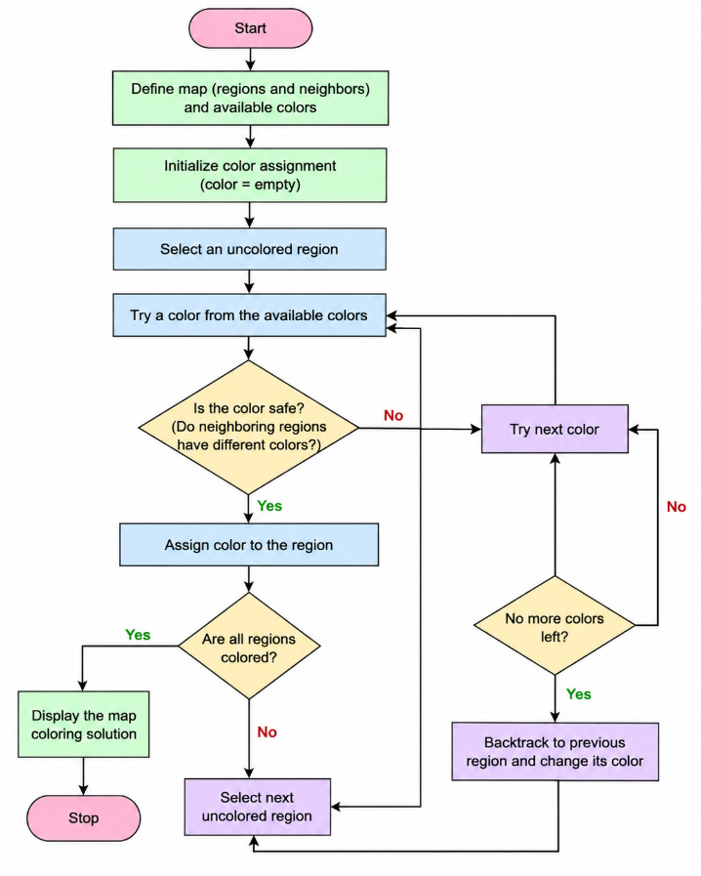
Python Code:
# Map colouring using CSP
# Map (neighbours)
map = {
'A': ['B', 'C'],
'B': ['A', 'C', 'D'],
'C': ['A', 'B', 'D'],
'D': ['B', 'C']
}
# Available colours
colours = ['Red', 'Green', 'Blue']
# Store colour assignment
colour = {}
def is_safe(region, selected_colour):
for neighbour in map[region]:
if neighbour in colour and colour[neighbour] == selected_colour:
return False
return True
def map_coloring(regions):
if len(colour) == len(regions):
return True
region = regions[len(colour)]
for selected_color in colours:
if is_safe(region, selected_colour):
colour[region] = selected_colour
if map_coloring(regions):
return True
del colour[region]
return False
# Solve the problem
regions = list (map. Keys ())
if map_coloring(regions):
print ("Map Colouring Solution:")
for region in colour:
print (region, "->", colour[region])
else:
print ("No solution exists")
Sample Output:
Map colouring Solution:
A -> Red
B -> Green
C -> Blue
D -> Red
Result:
